Analysis of Worksheet 1

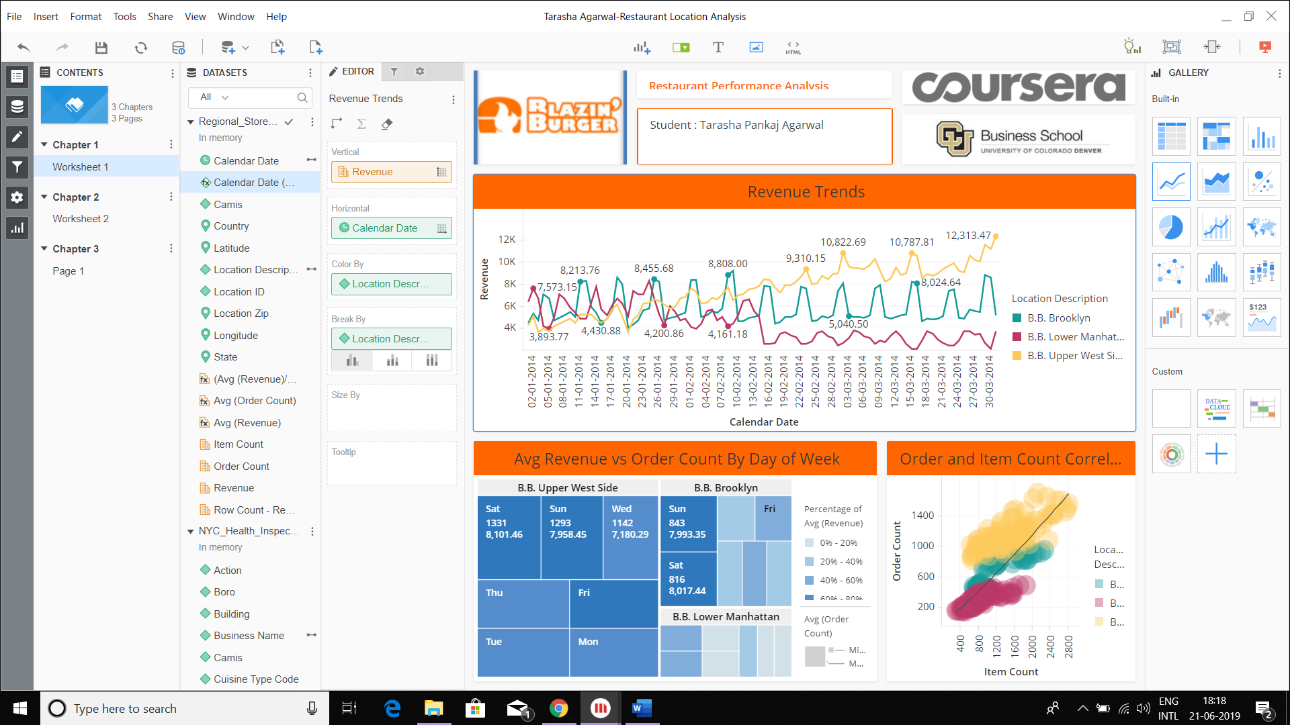

From the line graph for three locations, we can see that the revenue for all three locations is almost same until middle of February where they all start moving in different directions.

From the HeatMap, we can observe the Avg(Order Count) and Avg(Revenue) at specific day and location.

Bubble Chart shows the correlation between the Order and item count. We can see a trend line along 45 degrees, Green color dots of Upper West Side are mostly above the Trend Line , that means almost always order count is above line in Upper West Side. Whereas Red color Lower Manhattan values are below the line always.

Conclusion:

1. Restaurant at B.B.Upper West Side is performing the best.

2. Restaurant at B.B.Lower Manhattan is performing the worst.

Worksheet 2

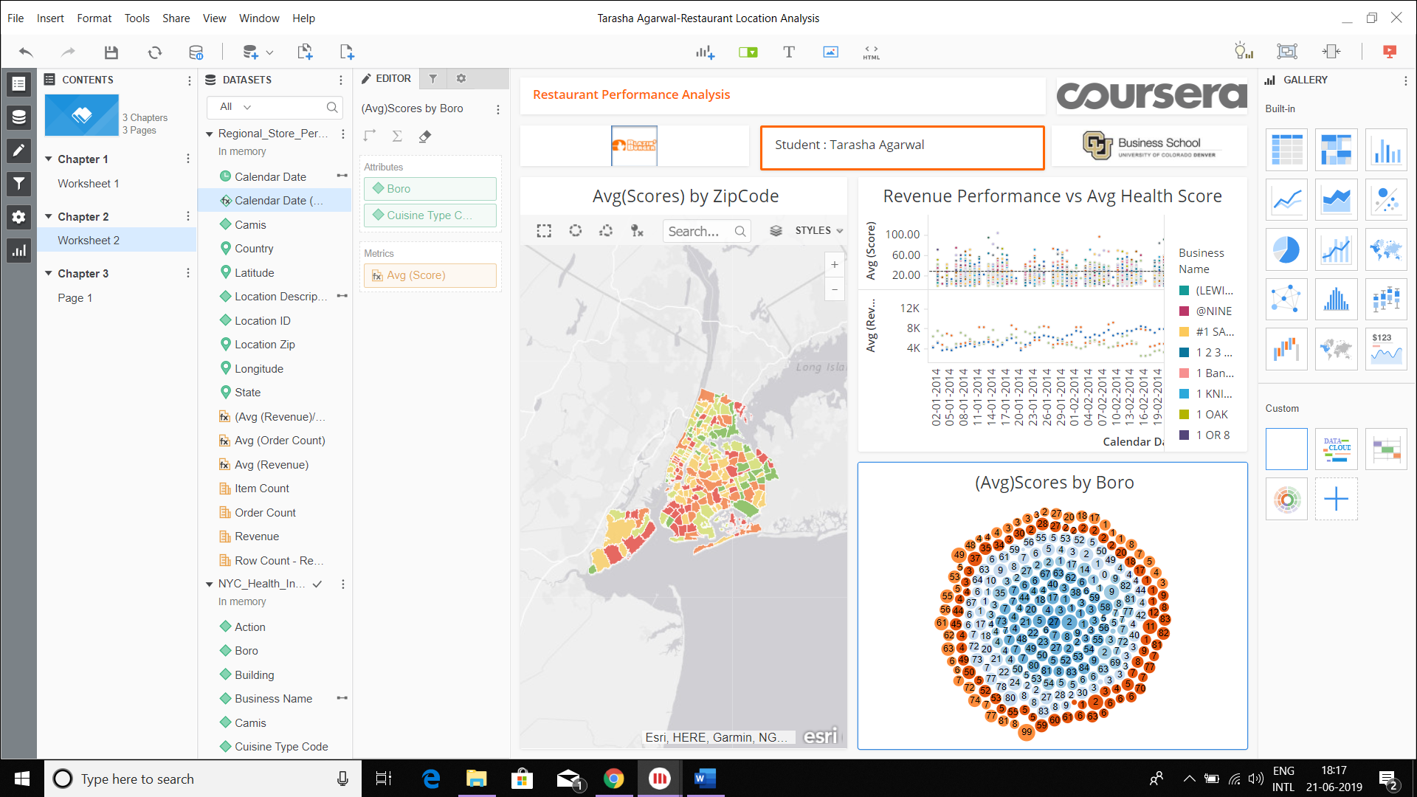

The map shows you the zip codes of New York colored by the average health inspection score of the restaurants in that area.

The lower the score, the better the grade, so lower numbers are green and higher numbers are red.

Most of the restaurants are in red meaning poor grade.

From the Bubble Chart it can be seen that higher scores is affecting the revenue.Thus, health scores should be looked into so that revenue performance can be improved

D3 Graph helps us to find whether there are any cuisines that fare good across multiple boro’s.

What more can we do?

We can analyse the contribution of restaurants in a particular zip code to average revenue by forming a pie chart as shown below

